Syllabus of BCA First Year First Semester for Academic Year 2015-16

 |  |  | Theory
Sl |  |  | CourseCode | Topic |  | Contacthrs/wk |  |  |  | Credit
 | No |  |  |  |  | L | T | P | Total
1 |  |  | BCA101 | Digital Electronics |  | 3 | 1 | 0 | 4 | 4
2 |  |  | BCA102 | Business Systems and Applications |  | 3 | 1 | 0 | 4 | 4
3 |  |  | BCA103 | Introduction to Programming |  | 3 | 1 | 0 | 4 | 4
4 |  |  | BCA104 | Mathematics-I |  | 3 | 1 | 0 | 4 | 4
5 |  |  | BCA105 | PC Software |  | 3 | 1 | 0 | 4 | 4
 |  |  |  | Totalof Theory |  |  |  |  | 20 | 20
 |  |  | Practical
6 |  |  | BCA191 | Programming Lab |  | - | - | 3 | 3 | 2
7 |  |  | BCA192 | Digital Electronics Lab |  | - | - | 3 | 3 | 2
 |  |  |  | Totalof Practical |  | l |  |  |  | 4
Sessional
8
8
8. |  |  | BCA181 |  | Seminar-I | 0 | 0 | 2 | 2 | 1
9. |  |  | BCA(GS)181 |  | General Studies - I | 3 | 1 | 0 | 4 | 4
 |  |  | Total of Sessional |  |  |  |  |  |  | 5
Total of Semester |  |  |  |  |  |  |  |  |  | 29

Syllabus of BCA First Year Second Semester for Academic Year 2015-16

 |  |  | Theory
Sl |  |  | CourseCode | Topic | Contacthrs/wk |  |  |  | Credit
 | No |  |  |  | L | T | P | Total
1 |  |  | BCA201 | Computer ArchitectureandSystemsSoftware | 3 | 1 | - | 4 | 4
2 |  |  | BCA202 | InformationSystemsAnalysis&Design | 3 | 1 | - | 4 | 4
3 |  |  | BCA203 | Computer Programming | 3 | 1 | - | 4 | 4
4 |  |  | BCA204 | Mathematics | 3 | 1 | - | 4 | 4
5 |  |  | BCA205 | English Languageand Communication | 3 | 1 | - | 4 | 4
 |  |  |  | Totalof Theory |  |  |  | 20 | 20
 |  |  | Practical
6 |  |  | BCA291 | Programming Lab | - | - | 3 | 3 | 3
7 |  |  | BCA292 | Computer ArchitectureandSystemsSoftware Lab | - | - | 3 | 3 | 3
8 |  |  | BCA281 | Business Presentation and Language Lab | - | - | 2 | 2 | 2
9 |  |  | BCA(GS)281 | General Studies - II | 3 | 1 | 0 | 4 | 4
 |  |  |  |  |  |  |  | 12 | 12
 |  |  |  |  |  |  |  | 32 | 32

Syllabus of BCA Second Year First Semester for Academic Year 2015-16

 |  |  | Theory
Sl |  |  | CourseCode | Topic | Contacthrs/wk |  |  |  | Credit
 | No |  |  |  | L | T | P | Total
1 |  |  | BCA301 | Operating Systems | 3 | 1 | - | 4 | 4
3 |  |  | BCA303 | Data Structures with C | 3 | 1 | - | 4 | 4
3 |  |  | BCA303 | Graphics & Internet | 3 | 1 | - | 4 | 4
4 |  |  | BCA304 | Mathematics for Computing | 3 | 1 | - | 4 | 4
5 |  |  | BCA305 | Management & Accounting | 3 | 1 | - | 4 | 4
 |  |  |  | Totalof Theory |  |  |  | 20 | 20
 |  |  | Practical/Sessional
6 |  |  | BCA391 | Internet & Computer Graphics Lab | - | - | 3 | 3 | 3
7 |  |  | BCA393 | Programming Lab (Data Structure with C) | - | - | 3 | 3 | 3
9 |  |  | BCA(GS)381 | General Studies - III | 3 | 1 | 0 | 4 | 4
 |  |  |  |  |  |  |  | 10 | 10
 |  |  |  |  |  |  |  | 30 | 30

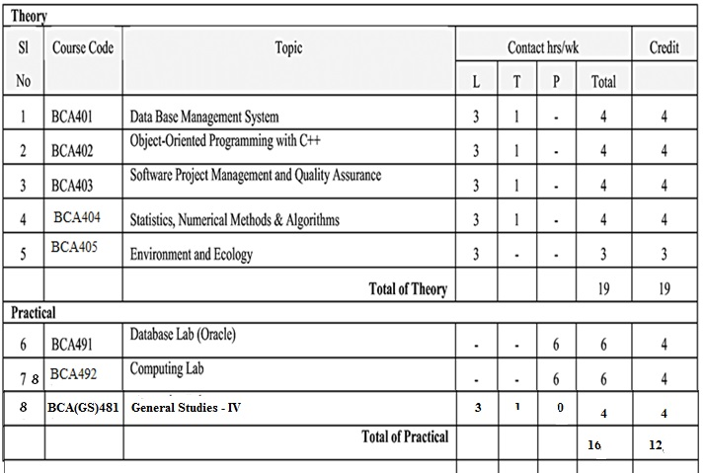

Syllabus of BCA Third Year First Semester for Academic Year 3015-16

 |  | Theory
Sl |  | Course Code |  | Topic |  |  | Contact hrs/wk |  |  | Credit
No |  |  |  |  |  | L | T | P | Total
1 |  | BCA501 |  | Data Communication & Computer Networks | 3 |  | 1 | - | 4 | 4
3 |  | BCA503 |  | Unix and Shell Programming | 3 |  | 1 | - | 4 | 4
3 |  | BCA503 |  | Windows Programming | 3 |  | 1 | - | 4 | 4
4 |  | BCA 504 |  | Elective - I | 3 |  | 1 | - | 4 | 4
 |  | A/B/C
5 |  | BCA505 |  | Values and Ethics of Profession | 3 |  | 1 | - | 3 | 3
 |  |  |  | Total of Theory |  |  |  |  | 19 | 19
 |  | Practical/Sessional
6 |  | BCA591 |  | Unix & Networking |  | - | - | 4 | 4 | 3
7 |  | BCA592 |  | Minor Project |  | - | - | 9 | 9 | 6
8 |  | BCA 593 |  | Industrial Training |  |  |  |  |  | 3
 | 9 | BCA(GS) 581 |  | General Studies - V |  | 3 | 1 | 0 | 4 | 4
 |  |  |  | Total of practical |  |  |  |  | 17 | 16
 |  |  | Total |  |  |  |  |  | 36 | 35

Syllabus of BCA Third Year Second Semester for Academic Year 3015-16

 |  |  | Theory
Sl |  |  | CourseCode | Topic | Contacthrs/wk |  |  |  |  |  | Credit
 | No |  |  |  | L | T | P |  | Total
1 |  |  | BCA E601/A/B/C | Elective - II | 3 | 1 | - |  | 4 |  | 4
2 |  |  | BCA E602/A/B/C | Elective - III | 3 | 1 | - |  | 4 |  | 4
 |  |  |  | Totalof Theory |  |  |  |  | 8 |  | 8
 |  |  | Sessional
6 |  |  | BCA693 | Major Project | - | - | 21 | 21 |  | 16
7 |  |  | BCA694 | Seminar | - | - | - | 3 |  | 2
8 |  |  | BCA695 | Comprehensive Viva-Voce | - | - | - | - |  | 4
9 |  |  | BCA(GS)681 | General Studies - VI | 3 | 1 | 0 | 4 |  | 4
 |  |  |  |  |  |  |  | 28 |  | 26
 |  |  |  |  |  |  |  | 36 |  | 34

